

**DATABASE SYSTEMS 5COSC020C**

Module Leader: Mr. Ragu Sivaraman

Group Number: L5 CS G23

Name: S S U Sachintha Chamod Piyathunga

IIT ID: 20221948

UOW ID: w2053013

# Abstract

This report focuses on the conceptualization, design, and implementation of a database system undertaken as part of the "Database System" module. It examines the systematic application of database design principles to address a real-world scenario, including the formulation of an Enhanced Entity-Relationship Diagram (EERD), data dictionary documentation, and a detailed analysis of relationships and constraints. The report emphasizes the importance of maintaining data integrity, scalability, and usability in database systems while aligning with the module's learning objectives. By applying methodologies taught throughout the module, the report presents a robust and comprehensive model tailored to the specific requirements of the case study of "Racketminster".

# Acknowledgement

I would like to express my heartfelt gratitude to Mr. Ragu Sivaraman, our module leader, for his invaluable guidance and support throughout the "Database System" module. His expertise and encouragement have been pivotal in deepening my understanding of database concepts and fostering my critical thinking skills.

I would also like to extend my thanks to my university, Informatics Institute of Technology (IIT), for providing an excellent learning environment and resources that made this project possible.

Lastly, I am deeply grateful to my family for their unwavering support, encouragement, and belief in my abilities. Their constant motivation has been a cornerstone of my academic journey.

# Table of contents

I. Abstract I

II. Acknowledgement II

III. Table of contents III

IV. List of Figures IV

V. List of Tables IV

VI. Abbreviations IV

VII. Declaration V

Business question and answers 1

Blackboard Uploaded Questions and Answers 2

1. CRITICAL EVALUATION & REFLECTIVE COMMENTARY. 5

1.1. Expanded Critical Evaluation of the Erroneous EERD, 5

1.2. Expanded Reflective Commentary: The Correct EERD, 8

1.3. Justification for Design Choices 11

2. ENTITIES 12

2.1. List of Entities 12

2.2. Entity Data Table 13

3. SPECIALISATIONS 13

**3.1.** **List of Specialized entities** 13

**3.2.** **Specialized Entity Data Table** 14

4. RELATIONSHIPS & MULTIPLICITIES 16

5. ATTRIBUTES & PRIMARY KEYS 23

6. Conceptual Enhanced Entity Relationship Diagram (EERD) 28

1. Court and Session 29

2. Court, Caretaker, and Equipment 29

3. Caretaker and Maintenance Report 29

5. Maintenance Report, Equipment Maintenance Report, and Court Maintenance Report 29

6. Court and Staff 29

7. Instructor and Supervised Session 29

8. Park and Caretaker 29

9. Block Booking and Unsupervised Session 30

10. Player, Booking, and Session 30

7. Part B - Logical ERD 31

# List of Figures

Figure 1 - Blackboard Uploaded Questions 2

Figure 2 - Blackboard Uploaded Answers 1 3

Figure 3 - Blackboard Uploaded Answers 2 4

Figure 4 - Insufficient Entity Representation 5

Figure 5 - Overlapping Relationships 1 6

Figure 6 - Overlapping Relationships 2 6

Figure 7 - Misplaced Attributes 7

Figure 8 - Logical Use of Specialization and Generalization 1 9

Figure 9 - Logical Use of Specialization and Generalization 2 9

Figure 10 - Improved Relationships and Cardinalities 10

Figure 11 - Conceptual Enhanced Entity Relationship Diagram 28

Figure 12 - Logical Enhanced Entity Relationship Diagram 31

# List of Tables

Table 1 - Entity Data Table 13

Table 2 - Specialized Entity Data Table 16

Table 3 - Relationships & Multiplicities Data Table 23

Table 4 - Attributes & Primary Keys Data Table 27

# Abbreviations

EERD - Enhanced Entity Relationship Diagram

# Declaration

I hereby declare that this report is my original work and will be submitted as part of my individual coursework for the DATABASE SYSTEMS module. I confirm that all sources of information used in this report have been properly acknowledged and cited, and no part of this work has been submitted elsewhere for academic or professional purposes.

|  |  |
| --- | --- |
| **Student Name** | : Silpadhipathi Senarath Upalige Sachintha Chamodh Piyathunga |
| **UoW ID Number** | : w2053013 |
| **IIT ID Number** | : 20221948 |

**Signature :**

# Business question and answers

**Question - 1.** How does the system distinguish between different types of caretakers responsible for park and court maintenance?

* **Answer - 1.** The system identifies caretakers by specialization. There are distinct entities for full-time and part-time caretakers, who may either be court caretakers or equipment caretakers. This classification ensures that each type of caretaker is allocated specific maintenance responsibilities, improving organization and resource allocation.

**Question - 2.** What role do instructors play in supervised sessions, and how are they categorized?

* **Answer - 2.** Instructors lead supervised sessions, either as part of personal training or group sessions. Instructors are categorized as full-time or part-time, allowing flexibility in session scheduling. This distinction helps manage instructor availability and ensures proper training resources for each session type.

**Question - 3.** How does the system track and manage court usage across different sports like tennis and pickleball?

* **Answer - 3.** Courts are classified based on their suitability for tennis, pickleball, or both. Each court’s type is documented, and the booking system ensures that players reserve courts aligned with their sports preferences. This categorization optimizes court allocation and reduces scheduling conflicts.

**Question - 4.** What is the structure and purpose of block bookings, and how does the system track these sessions?

* **Answer - 4.** Block bookings allow players to reserve multiple unsupervised sessions ahead of time. The system maintains a sequence of these bookings, enabling continuity and easier access to preferred playtimes. This feature is beneficial for players looking to

**Question - 5.** How are equipment pieces assigned and tracked across different courts, and what information is logged for each piece?

* **Answer - 5.** Each piece of equipment is assigned to a specific court. Equipment is categorized as either fixed or movable, with a unique record for each item. Logs include maintenance history and specific allocation details, helping track equipment status and movement between courts.

**Question - 6.** What is the purpose of categorizing supervised group sessions into fitness-play, group coaching, and social fun, and how does it benefit players?

* **Answer - 6.** Categorizing supervised group sessions allows players to choose sessions aligned with their objectives. Fitness play focuses on physical activity, group coaching on skill improvement, and social fun on social engagement within a relaxed environment. This structure enhances player satisfaction by addressing diverse player interests and fostering a well sporting experience.

# Blackboard Uploaded Questions and Answers

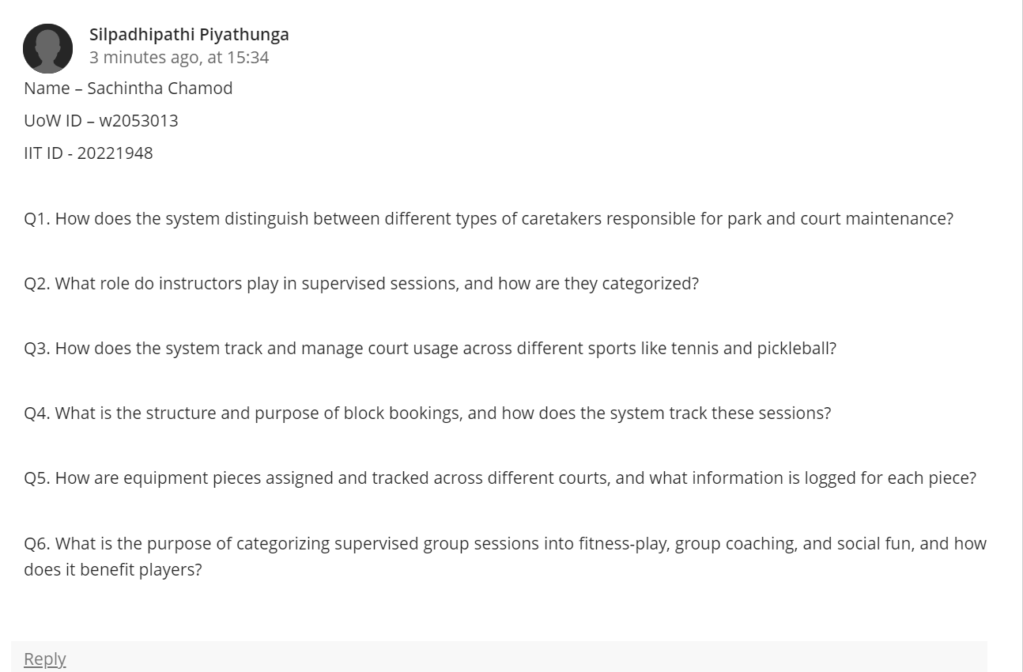

Figure 1 - Blackboard Uploaded Questions

Figure 2 - Blackboard Uploaded Answers 1

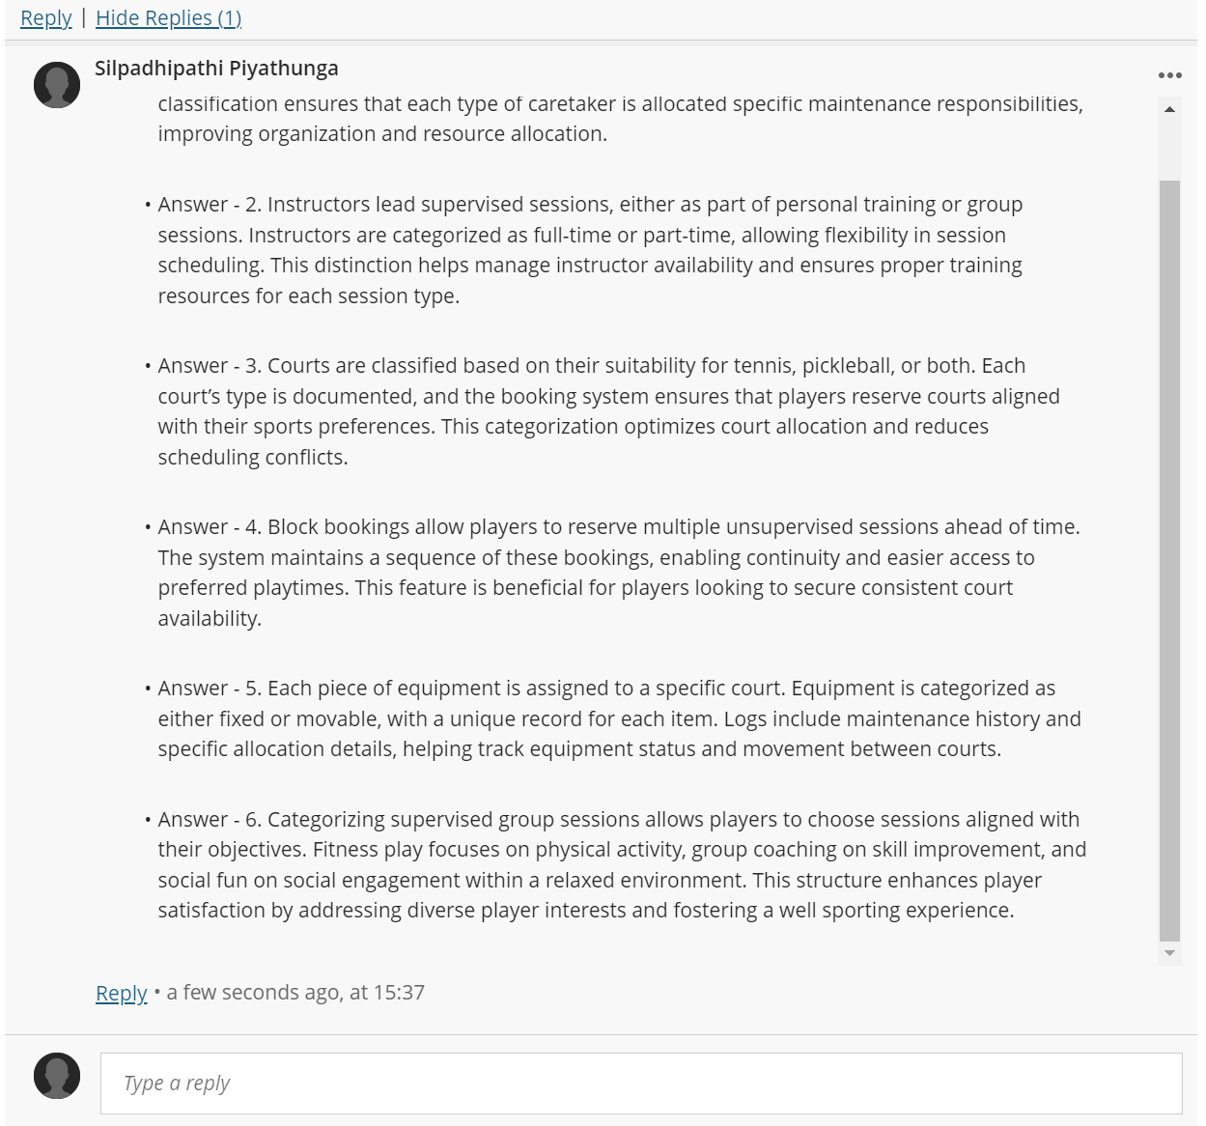

Figure 3 - Blackboard Uploaded Answers 2

**Part A - Questions**

**QUESTION 1,**

# CRITICAL EVALUATION & REFLECTIVE COMMENTARY.

## Expanded Critical Evaluation of the Erroneous EERD,

The A.2. initial EERD demonstrates significant shortcomings in its ability to serve as a high-quality conceptual model. Several key issues are evident,

1. Lack of Contextual Integrity

* The entities in the basic EERD fail to fully address the domain-specific requirements of a facility like “Racketminster”. For instance, there is no clear differentiation between essential components such as parks, courts, equipment, and sessions. Instead, these relationships are oversimplified and lack clarity. Moreover, the inclusion of relationships such as "Recommends" (between players) is poorly contextualized, leading to a disconnect from the underlying business processes and logic.

2. Insufficient Entity Representation

* While the EERD includes entities such as "Player" and "Instructor," there is no attempt to distinguish between roles or provide deeper classification. For example, players who may also act as coaches or variations such as advanced versus beginner players are not considered. Similarly, the "Caretaker" entity is overly generic and does not specify whether caretakers are responsible for parks, courts, or both, leading to ambiguity in role assignments.

Figure 4 - Insufficient Entity Representation

3. Overlapping Relationships

* The relationships between entities such as "Session," "Booking," and "Player" are poorly defined and lack proper structure. Several key issues emerge.

Figure 5 - Overlapping Relationships 1

* The EERD does not differentiate between "block bookings" (group-based, longer-term reservations) and "individual bookings."
* There is no indication of whether "Session" links to individual or group-based bookings, resulting in confusion about the intended purpose of these relationships.
* Relationships such as "Has" and "Logged" are ambiguous, making it unclear how they functionally integrate maintenance logs, bookings, and courts.

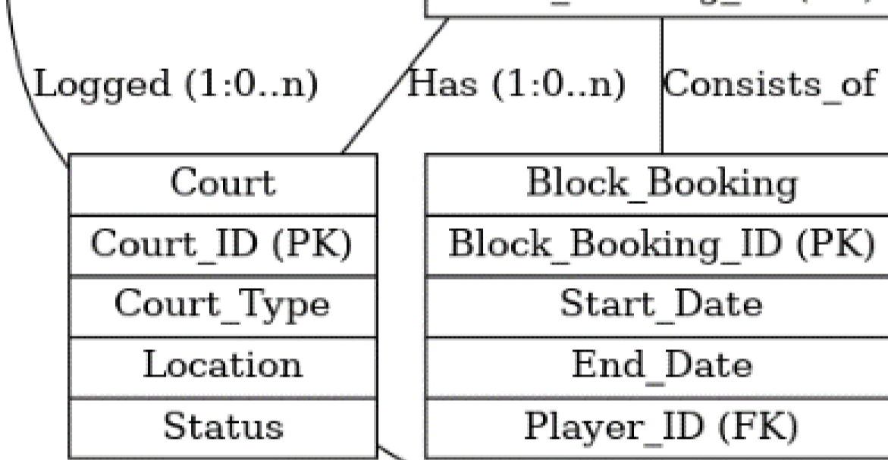

Figure 6 - Overlapping Relationships 2

4. Misplaced Attributes

* The placement of attributes in the EERD is problematic and creates potential for redundancy and inconsistency.
* Attributes such as "Court_Type" are redundantly tied to the "Court" entity, ignoring the possibility that multiple sessions may use the same court.
* The attribute "Log_Description" within the "Maintenance_Log" entity does not specify whether it pertains to equipment, court conditions, or other maintenance activities, reducing its clarity and usability.

Figure 7 - Misplaced Attributes

5. Poor Scalability and Extensibility

* The design lacks flexibility and does not support scalability for future expansions.
* Adding new session types, player roles, or other classifications would require significant rework of the model.
* The absence of modular relationships, particularly for entities such as equipment, caretakers, and parks, severely limits the system's capacity to evolve alongside organizational needs.

6. Incorrect Multiplicities

* The EERD's representation of multiplicities is either missing or inaccurate, leading to critical design flaws.
* For example, while a court is likely to host many bookings, the "Has" relationship does not explicitly indicate this.
* Similarly, a player may recommend multiple other players, but the relationship lacks any defined cardinality to reflect this possibility.

By failing to address these foundational issues, the A.2. initial EERD does not provide a reliable or accurate representation of the system's requirements, thereby hindering its ability to support the functional and operational needs of the domain.

## Expanded Reflective Commentary: The Correct EERD,

The creation of the improved EERD for the “Racketminster” system involved a meticulous process to address the deficiencies of the initial design and construct a robust conceptual model. The following outlines the approach and rationale behind the improved design,

1. Structured Identification of Domain Requirements

* The improved design began with a thorough analysis of the system's domain-specific requirements. Key entities such as courts, parks, players, and equipment were identified, along with their respective relationships (e.g., bookings, sessions, and maintenance activities).
* Added Entities - Domain-specific entities like "Equipment," "Park," and "Block_Booking" were included to better capture the details of the system.
* Distribution Attributes - Attributes were assigned logically to their respective entities to avoid redundancy and ensure clarity in data representation.

2. Logical Use of Specialization and Generalization

* Specialization and generalization hierarchies were introduced to address role-specific or category-specific properties.
* Caretaker Specialization - Caretakers were categorized as "Full-Time" and "Part-Time" to reflect their varying responsibilities. For example, full-time caretakers oversee the entire park, while part-time caretakers manage specific courts.

Figure 8 - Logical Use of Specialization and Generalization 1

* Session Types - Sessions were classified into "Supervised" and "Unsupervised," with further subdivisions such as "Fitness Play" and "Group Coaching" to accommodate a range of user needs.
* Instructor Hierarchy - The "Instructor" entity was divided into "Full-Time" and "Part-Time" instructors, reflecting their teaching capacities and availability.

Figure 9 - Logical Use of Specialization and Generalization 2

3. Improved Relationships and Cardinalities

* Relationships were restructured to reflect real-world interactions more accurately, and meaningful cardinalities were added to ensure data integrity.
* Player Recommendations - A "Player" can recommend multiple other players, and this relationship is captured within the "Player" entity.

Figure 10 - Improved Relationships and Cardinalities

* Booking and Sessions - A "Booking" consists of multiple sessions, and every booking is tied to either an individual player or a block booking.
* Court Usage - Courts were assigned a one-to-many relationship with bookings, while maintenance logs were linked to both courts and caretakers, ensuring clarity in these interactions.

4. Inclusion of Overlooked Entities

* Several domain-specific entities absent from the original EERD were added to enhance the model’s comprehensiveness.
* Equipment - An "Equipment" entity was introduced to manage the upkeep of items such as rackets, nets, and scoreboards. This entity is linked to both courts and maintenance activities.
* Park - Parks were separated from courts, with parks linked to caretakers and courts tied to bookings. This ensures an accurate representation of the hierarchical structure within the facility.

5. Improved Attribute Placement

* Attributes were assigned carefully to their respective entities to eliminate redundancy and improve clarity.
* Court Attributes - Attributes such as "Court_Type" are now part of the "Court" entity, ensuring seamless integration with session and booking data.
* Maintenance Log Attributes - The "Maintenance_Log" entity now includes detailed fields such as "Log_Description" and is linked directly to courts and caretakers to provide a complete overview of maintenance activities.

6. Scalability and Extensibility

* The improved EERD was designed with scalability and flexibility in mind, allowing for future enhancements without significant redesign.
* Session and Booking Flexibility - The modularization of session categories and booking types ensures the system can accommodate new session formats or court types with
* Extensible Relationships - Relationships for players, bookings, and equipment were structured to support the addition of new functionalities, ensuring the system remains adaptable to evolving requirements.

## Justification for Design Choices

The design choices made for the improved EERD are based on ensuring a robust, scalable, and accurate representation of the real-world components and interactions within the “Racketminster” system. Below is the rationale behind these choices.

**Entities**

* The defined entities represent the key components of a racket sports facility, such as courts, players, caretakers, parks, and equipment. Each entity is designed with a clear purpose, ensuring completeness and relevance to the domain. This ensures that the model captures all essential aspects of the system.

**Specializations**

* Specializations were incorporated to add flexibility and adaptability to the design. This allows for easier modification or expansion, such as introducing new caretaker roles or session types. The specializations reflect the real-world diversity in roles, such as distinguishing between full-time and part-time caretakers or supervised and unsupervised sessions.

**Relationships**

* The relationships in the EERD were structured to accurately capture key interactions and dependencies within the system. By avoiding oversimplifications, the design ensures that all processes, such as bookings, maintenance activities, and player recommendations, are logically connected and clearly defined.

**Attributes and Primary Keys**

* Attributes were carefully selected to minimize ambiguity while capturing all necessary details relevant to the system. Primary keys were assigned to each entity to ensure uniqueness and maintain data integrity. This prevents redundancy and supports efficient data retrieval and management.

**Multiplicity Constraints**

* Multiplicity constraints were defined accurately to reflect real-world constraints and interactions. For instance, a player can make multiple bookings, but each booking must belong to only one player. Such constraints ensure that the relationships in the EERD align with real-world scenarios and maintain the model's logical consistency. By adhering to these principles, the improved EERD ensures that the conceptual model is robust, extensible, and fully aligned with the requirements of the “Racketminster” project.

**QUESTION 2**

# ENTITIES

## List of Entities

* Park
* Court
* Session
* Player
* Booking
* Staff.
* Equipment
* Maintenance Report

## Entity Data Table

|  |  |
| --- | --- |
| Entity Name | Brief Explanation |
| Park | Represents the overarching facility or area that contains multiple courts and associated equipment. |
| Court | Represents individual sports courts, such as tennis, pickleball, or multi-use courts, located within a park. |
| Session | Represents scheduled activities conducted on courts, including group training, fitness play, or coaching sessions. |
| Player | Represents individuals who utilize the facilities, participate in sessions, or book courts. |
| Booking | Represents reservations made by players for courts or sessions, including both individual and block bookings. |
| Staff | Represents personnel responsible for managing and maintaining the park, courts, or assisting with sessions, such as caretakers and instructors. |
| Equipment | Represents items used within the facility, such as rackets, nets, scoreboards, or tools for maintenance. |
| Maintenance Report | Represents detailed logs of maintenance activities performed on courts, parks, or equipment by caretakers or staff. |

Table 1 - Entity Data Table

**QUESTION 3**

# SPECIALISATIONS

## **List of Specialized entities**

* Multi useable Court
* Tennis Court
* Pickleball Court
* Block Booking
* Single Session Booking
* Supervised Session
* Unsupervised Session
* Fitness Play Session
* Group Coaching Session
* Social Fun Session
* Single Session
* Double Session
* Full Time Instructor
* Part Time Instructor
* Instructor
* Caretaker
* Court Caretaker
* Equipment Caretaker
* Full Time Caretaker
* Part Time Caretaker
* Court Maintenance Report
* Equipment Maintenance Report
* Movable Equipment
* Fixed Equipment

## **Specialized Entity Data Table**

|  |  |  |
| --- | --- | --- |
| General entity | Specialized entity | Brief explanation |
| Court | Multi usable Court | Represents courts designed to accommodate multiple sports activities, such as basketball and badminton. |
| Tennis Court | Refers to courts that are specifically designed for playing tennis. |
| Pickleball Court | Refers to courts specifically designed for the game of pickleball. |
| Booking | Block Booking | Describes reservations that cover multiple sessions or courts over an extended period. |
| Single Session Booking | Represents individual bookings made for single sessions. |
| Session | Supervised Session | Refers to sessions conducted under the guidance or supervision of an instructor or coach. |
| Unsupervised Session | Refers to sessions where players participate without any supervision from an instructor. |
| Group Session | Fitness Play Session | Refers to group sessions that focus on general fitness and recreational activities. |
| Group Coaching Session | Refers to group sessions aimed at skill development through coaching. |
| Social Fun Session | Refers to group sessions organized for casual play and social interaction. |
| Unsupervised Session | Single Session | Represents unsupervised sessions with one individual participant. |
| Double Session | Represents unsupervised sessions involving two participants. |
| Instructor | Full Time Instructor | Refers to instructors who are employed on a full-time basis at the facility. |
| Part Time Instructor | Refers to instructors who are employed on a part-time basis at the facility. |
| Staff | Instructor | Represents staff members responsible for conducting training sessions and guiding players. |
| Caretaker | Refers to staff members tasked with maintaining courts, parks, and equipment. |
| Caretaker | Court Caretaker | Refers to caretakers specifically responsible for maintaining courts. |
| Equipment Caretaker | Refers to caretakers assigned to the upkeep and repair of equipment. |
| Full Time Caretaker | Represents caretakers who work full-time within the facility. |
| Part Time Caretaker | Represents caretakers who work on a part-time basis within the facility. |
| Maintenance Report | Court Maintenance Report | Refers to maintenance reports focusing on the upkeep and repair of courts. |
| Equipment Maintenance Report | Refers to maintenance reports focusing on the upkeep and repair of equipment. |
| Equipment | Movable Equipment | Represents portable equipment, such as rackets, nets, and scoreboards, used in the facility. |
| Fixed Equipment | Refers to fixed installations, such as lighting and permanent seating, used in the facility. |

Table 2 - Specialized Entity Data Table

**QUESTION 4**

# RELATIONSHIPS & MULTIPLICITIES

Entity Data Table

|  |  |  |  |  |  |
| --- | --- | --- | --- | --- | --- |
| **Entity name** | **Multiplicity** | **Relationship** | **Multiplicity** | **Entity name** | **Brief justifications for the multiplicity** |
| Park | 1..1 | has | 1..0 | Court | 1. Each park is associated with multiple courts.  2. Parks may exist without courts initially.  3. Courts cannot exist without being linked to a park.  4. Parks provide administrative and physical locations for courts. |
| Caretaker | 1..* | assigned | 1..* | Park | 1. Caretakers are assigned to manage one or more parks.  2. Parks often require multiple caretakers based on their size and maintenance needs.  3. Each caretaker focuses on specific parks for accountability.  4. Parks depend on caretakers for maintenance and upkeep of facilities. |
| Court | 1..* | provides | 0..* | Session | 1. Courts are utilized to host sessions for various activities.  2. Some courts may not have any sessions at specific times.  3. Each session is linked to a specific court.  4. Sessions are organized based on the availability and functionality of courts. |
| Player | 1..* | Booking | 1..* | Session | 1. Players make bookings to participate in sessions.  2. Sessions can include multiple players.  3. Bookings are necessary to manage player participation in sessions.  4. Sessions rely on bookings to ensure proper organization and attendance. |
| Block Booking | 1..1 | reserves | 1..* | Unsupervised Session | 1. Block bookings reserve multiple unsupervised sessions for streamlined scheduling.  2. Unsupervised sessions must be part of a booking to allocate resources efficiently.  3. A single block booking can organize numerous unsupervised sessions.  4. Unsupervised sessions are better managed through centralized block bookings. |
| Instructor | 0..* | conducts | 1..* | Supervised Session | 1. Instructors are responsible for conducting supervised sessions.  2. A supervised session requires at least one instructor to oversee its execution.  3. Instructors may conduct multiple sessions as part of their duties.  4. Supervised sessions rely on instructors to ensure proper instruction and management. |
| Court | 1..* | hire | 1..* | Staff | 1. Courts hire staff to support operations and sessions.  2. Staff may work across multiple courts depending on their role.  3. Courts depend on staff to ensure smooth functioning and service delivery.  4. Staff assignments are flexible to meet the needs of different courts. |
| Caretaker | 0..* | is given | 1..* | Maintenance Report | 1. Caretakers are provided with maintenance reports to address issues in the park.  2. Maintenance reports can involve multiple caretakers for complex tasks.  3. Each caretaker addresses specific tasks outlined in the maintenance reports.  4. Maintenance reports are critical for ensuring park facilities remain operational and safe. |
| Equipment | 1..1 | possess | 0..* | Equipment Maintenance Report | 1. Each piece of equipment must have maintenance records for tracking issues and resolutions.  2. Equipment can have multiple maintenance reports over its lifespan.  3. Maintenance reports provide detailed documentation of equipment conditions and repairs.  4. Proper maintenance ensures the longevity and usability of equipment. |
| Court | 1..1 | hold | 0..* | Court Maintenance Report | 1. Courts are required to maintain records of all maintenance activities for accountability.  2. Maintenance reports may not exist for courts that are newly constructed or unused.  3. Each maintenance report is specific to an individual court to document its condition.  4. Courts use these reports to ensure timely upkeep and prevent disruptions to operations. |
| Player | 0..1 | Recommends | 0..* | Player | 1. Players can recommend other players for sessions or activities.  2. Recommendations are optional and may not always occur.  3. Players can receive multiple recommendations from others.  4. Recommendations foster a sense of community and collaboration among players. |

Table 3 - Relationships & Multiplicities Data Table

**QUESTION 5**

# ATTRIBUTES & PRIMARY KEYS

Entity Data Table

|  |  |  |
| --- | --- | --- |
| Entity name | Attributes | Brief explanation |
| Park | -parkID {PK} | - “parkID” serves as the unique identifier for each park. |
| -parkName | - “parkName” provides the name of the park. |
| -location | - “location” specifies the park's address. |
| -status | - “status” indicates whether the park is operational or under maintenance. |
| Court | -courtID {PK} | - “courtID” uniquely identifies each court. |
| -courtName | - “courtNam”e and “courtType” specify the court's identity and type. |
| -courtType |
| -location | - “location” and “status” provide court details. |
| -status |
| -courtCapacity | - “courtCapacity” indicates maximum usage capacity. |
| Multi usable Court | -courtSize | - “courtSize” specifies the dimensions of the multi-usable court. |
| -netType | - “netType” defines the type of net available. |
| Tennis Court | -racketType | - “racketType” specifies the type of tennis rackets allowed. |
| -ballCount | - “ballCount” indicates the number of tennis balls available for play. |
| Pickleball Court | -racketSize | - “racketSize” defines the size of the rackets used in pickleball courts. |
| Player | -playerID {PK} | - “playerID” uniquely identifies each player. |
| -playerName | - Thies attributes capture personal and contact details of players. |
| -playerEmail |
| -playerAddress |
| -playerTelNo |
| Block Booking | -blockBookingCount | - “blockBookingCount” tracks the number of block bookings. |
| -numberOfSessions | - “numberOfSessions” captures the total sessions booked in the block. |
| Single Session Booking | -sessionPurpose | - “sessionPurpose” defines the aim of the session. |
| Session | -sessionID {PK} | - “sessionID” uniquely identifies each session. |
| -sessionName | - Thies all attributes record the details of the session, including its type, date, and player participation. |
| -sessionType |
| -date |
| -time |
| -sessionCategory |
| -playerCount |
| Supervised Session | -sessionGoal | - “sessionGoal” specifies the main objective of the supervised session. |
| Personal Session | -playerFocusingArea | - “playerFocusingArea” indicates the personal development area for the player. |
| Group Session | -maximumPlayerCount | - “maximumPlayerCount” specifies the upper limit of players allowed in a group session. |
| Fitness Play Session | -staminaLevel | - “staminaLevel defines the physical endurance required for the session. |
| Group Coaching Session | -numberOfCoaches | - “numberOfCoaches” specifies the total number of coaches required for the session. |
| Social Fun Session | -funGames | - “funGames” lists the recreational games included in the session. |
| Unsupervised Session | -sessionPurpose | - “sessionPurpose” outlines the objectives of the unsupervised session. |
| Single Session | -trainingDuration | - “trainingDuration” specifies the length of the single session. |
| DoubleSession | -numberOfTrainingRounds | - “numberOfTrainingRounds” captures the total training rounds within the session. |
| Staff | -staffID {PK} | - “staffID” uniquely identifies each staff member. |
| -staffName | - All these attributes are document their contact and identification details. |
| -staffEmail |
| -staffAddress |
| -staffTelNo |
| Instructor | -instructorAvailability | - “instructorAvailability” indicates the working hours of the instructor. |
| -specializedSoprt | - “specializedSport” records their area of expertise. |
| -instructorSalary | - The “instructorSalary” specifies their earnings. |
| Full Time Instructor | -salaryScale | - “salaryScale” defines the pay range. |
| -holidayAllowance | - “holidayAllowance” records vacation benefits. |
| Part Time Instructor | -hourlyRate | - “hourlyRate” defines the payment per hour for part-time instructors. |
| Caretaker | -caretakerSalary | - “caretakerSalary” specifies the pay received by the caretaker. |
| Court Caretaker | -workExperience | - “workExperience” records the total experience of the court caretaker. |
| Equipment Caretaker | -workingHours | - “workingHours” tracks the daily hours worked by the caretaker. |
| Full Time Caretaker | -salaryScale | - “salaryScale” defines the pay range. |
| -holidayAllowance | - “holidayAllowance” records vacation benefits for full-time caretakers. |
| Part Time Caretaker | -hourlyRate | - “hourlyRate” indicates the pay per hour for part-time caretakers. |
| Equipment | -equipmentID {PK} | - “equipmentID” uniquely identifies each equipment item. |
| -equipmentName | - All these attributes are document its type, status, and purpose. |
| -equipmentType |
| -status |
| Fixed Equipment | -equipmentCount | - “equipmentCount” records the total number of fixed equipment items. |
| Movable Equipment | -equipmentSize | - “equipmentSize” specifies the dimensions of movable equipment items. |
| Maintenance Report | -maintenanceReportID {PK} | - “maintenanceReportID” serves as a unique identifier. |
| -maintenanceReportName | - All these attributes provide details about the maintenance activity, including date, time, and status. |
| -maintenanceReportDate |
| -maintenanceReportTime |
| -maintenanceReportStatus |
| -reportLogDiscription |
| Equipment Maintenance Report | -equipmentCondition | - “equipmentCondition” describes the state of the equipment being maintained. |
| Court Maintenance Report | -courtSize | - “courtSize” indicates the dimensions of the court. |
| -numberOfCourts | - “numberOfCourts” specifies the total courts being maintained. |

Table 4 - Attributes & Primary Keys Data Table

**QUESTION 6**

1. 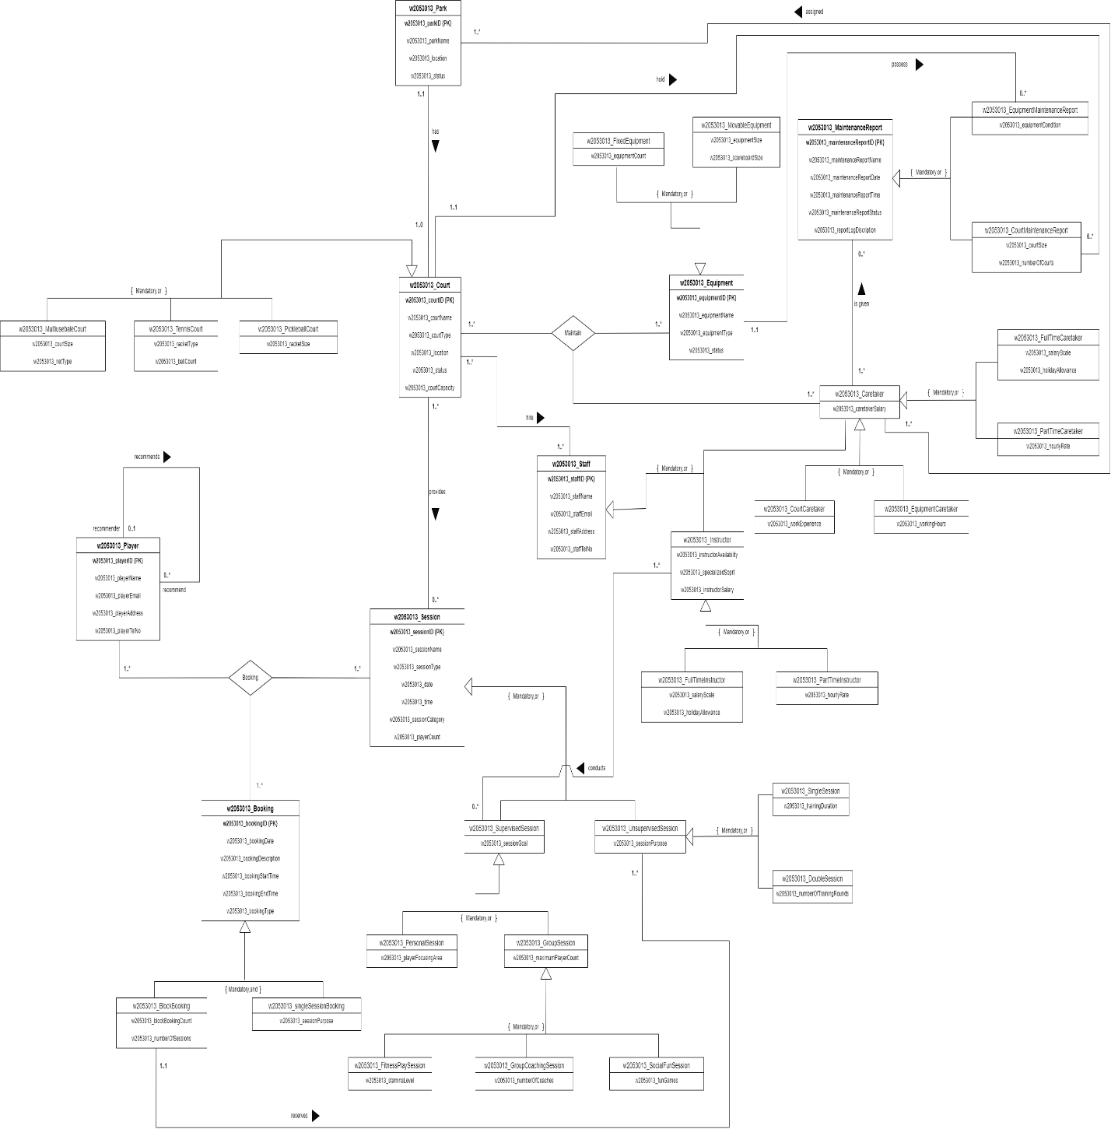Conceptual Enhanced Entity Relationship Diagram (EERD)

Figure 11 - Conceptual Enhanced Entity Relationship Diagram

Link (Please use IIT email if need to access) - <https://drive.google.com/file/d/170tWHzqUU9MWG5k-WsIklemAc3QpRLwO/view?usp=drive_link>

Assumptions of EERD

## Court and Session

* Each court may provide no sessions, but it can also be associated with multiple sessions. A session, however, must be provided by at least one court.

## Court, Caretaker, and Equipment

* A caretaker is responsible for maintaining both courts and equipment. Each caretaker must hold at least one court and one piece of equipment.

## Caretaker and Maintenance Report

* A caretaker can be given zero or many maintenance reports. Each maintenance report must be given to at least one caretaker and can be linked to multiple caretakers.

1. Staff, Caretaker, and Instructor

* Caretakers and instructors are staff members associated with courts. Additionally, other staff members may also be associated with courts.

## Maintenance Report, Equipment Maintenance Report, and Court Maintenance Report

* Caretakers are required to be given separate maintenance reports for equipment and courts. Each maintenance report must include an equipment maintenance report and a court maintenance report. At least one of these two reports is required within each maintenance report.

## Court and Staff

* Each court is required to have at least one staff member and may have multiple staff members. Similarly, each staff member can be hired to work with at least one court and may work with multiple courts.

## Instructor and Supervised Session

* Instructors may conduct zero or multiple supervised sessions. Each supervised session must have at least one instructor and may have multiple instructors.

## Park and Caretaker

* Each caretaker is assigned to at least one park and may be assigned to multiple parks. Each park must have at least one caretaker and may have multiple caretakers.

## Block Booking and Unsupervised Session

* Players reserve block bookings that include at least one unsupervised session and may include multiple unsupervised sessions. Each unsupervised session can be reserved by one block booking at most.

## Player, Booking, and Session

* Each player books at least one session and may book multiple sessions. A session can be booked by at least one player through at least one booking and may involve multiple bookings. Each booking must include at least one session and must be associated with at least one player, with the possibility of including multiple players.

# Part B - Logical ERD

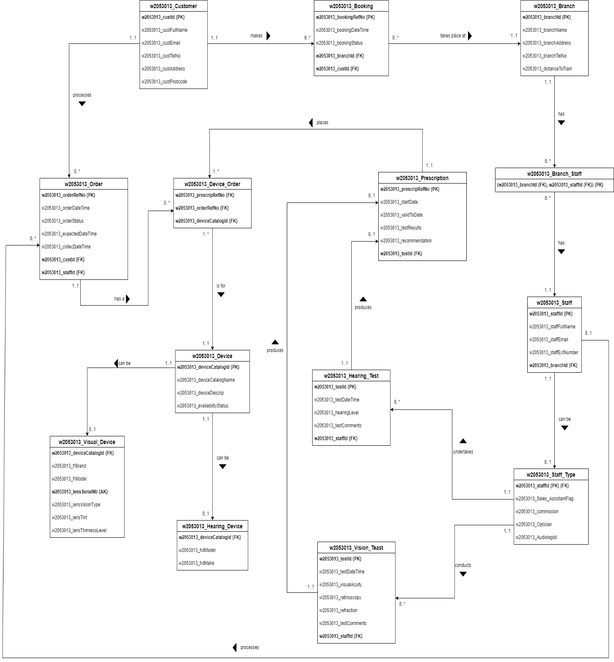

Figure 12 - Logical Enhanced Entity Relationship Diagram

Link (Please use IIT email if need to access) - <https://drive.google.com/file/d/1KGB2cdFOjJw9uCAXTfHY8g9VYw_APgL4/view?usp=drive_link>